**TEAM OK NA TO (NAME)**

**DATABASE**

**LECTURER**

**LOGGING LOGS**

**CLASSES**

**STUDENT**

**ATTENDANCE**

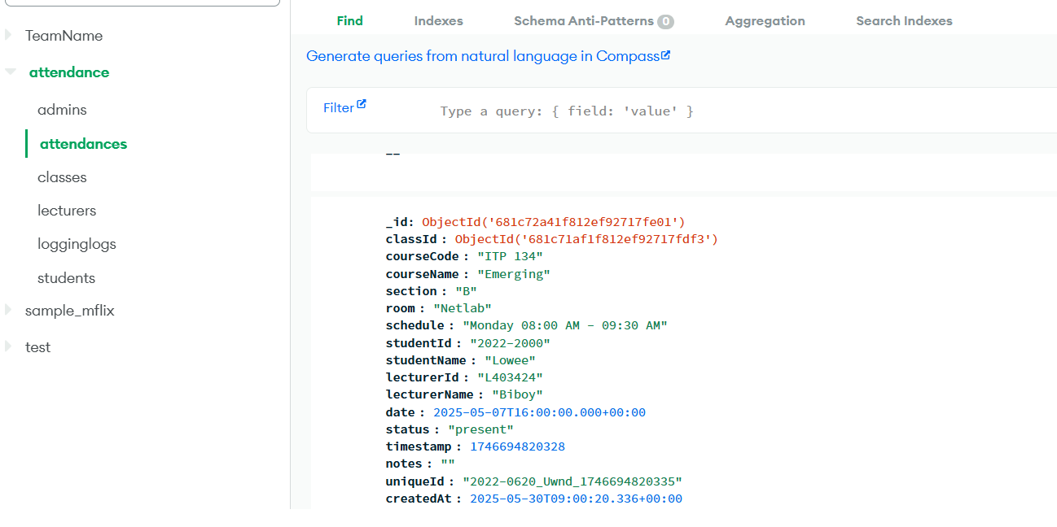

**ADMIN**

